**Lesson 4**

**What is the Visual Studio Code used for?**

VS Code is an open-source Integrated Development Environment that can be virtually used with any programming language.

Visual studio code can be downloaded by visiting this [link](https://code.visualstudio.com/) and pressing the button Download for Windows.

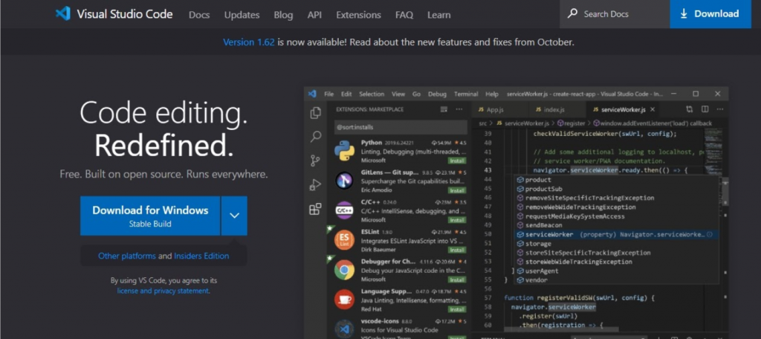

Once we have successfully installed VS Code we should now proceed to install the Python extension. The Python extension for Visual Code studio can be installed from the Visual studio marketplace by pressing **Ctrl + Shift + x**and searching the word **Python** in the search bar at the top.

### How to run a Python program in VS Code by using extensions

Select the extension with the highest number of downloads by Microsoft and press the install button.

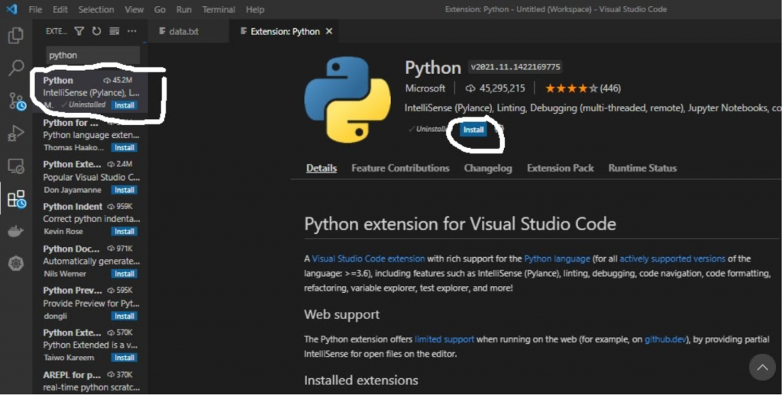

Once we have installed the Python extension we can now proceed to write Python codes. The standard way of writing and running Python programs in Python is by using the green button at the far right corner of the IDE. Once the code is executed the output is displayed in the terminal at the bottom.

